Daniel Fryer
Mod 3 Assignment
8/30/2026

Form:
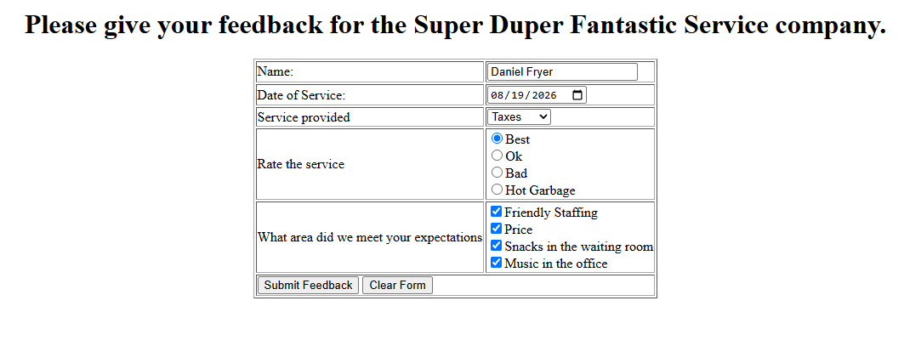

Results:
